- List all employees with their warehouse locations. Show employee first name, last name, and warehouse location.

Query: SELECT e.first_name, e.last_name, w.location AS warehouse_location FROM employees e INNER JOIN warehouses w ON e.warehouse_id = w.warehouse_id;

Result:
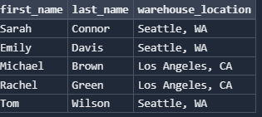

- List all products in the 'Electronics' category. Show product name, price, and stock quantity.

Query: SELECT product_name, price, stock_quantity FROM products WHERE category = 'Electronics';

Result:
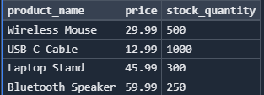

- Find all orders placed after 2024-01-01. Show order ID, customer full name (first and last name combined), and order date.

Query: SELECT o.order_id, c.first_name || ' ' || c.last_name AS customer_name, o.order_date FROM orders o INNER JOIN customers c ON o.customer_id = c.customer_id WHERE o.order_date > '2024-01-01';

Result:
